**QUESTION NO 1:**

class Recipe:

def __init__(self, name, ingredients, instructions, dietary_restrictions=None):

self.name = name

self.ingredients = ingredients

self.instructions = instructions

self.dietary_restrictions = dietary_restrictions if dietary_restrictions else []

def add_ingredient(self, ingredient):

self.ingredients.append(ingredient)

def remove_ingredient(self, ingredient):

if ingredient in self.ingredients:

self.ingredients.remove(ingredient)

else:

print(f"{ingredient} is not in the ingredients list.")

def check_matching_ingredients(self, other_recipe):

matching_ingredients = set(self.ingredients) & set(other_recipe.ingredients)

return list(matching_ingredients)

def format_recipe_description(self):

formatted_description = f"Recipe: {self.name}\n\nIngredients:\n"

for ingredient in self.ingredients:

formatted_description += f"- {ingredient}\n"

formatted_description += f"\nInstructions:\n{self.instructions}\n"

formatted_description += f"Dietary Restrictions: {', '.join(self.dietary_restrictions)}"

return formatted_description

def compare_on_criteria(self, other_recipe, criteria):

if criteria == 'name':

return self.name == other_recipe.name

elif criteria == 'ingredients':

return set(self.ingredients) == set(other_recipe.ingredients)

elif criteria == 'instructions':

return self.instructions == other_recipe.instructions

elif criteria == 'dietary_restrictions':

return set(self.dietary_restrictions) == set(other_recipe.dietary_restrictions)

else:

return False # Invalid criteria

def __eq__(self, other):

return (

self.name == other.name and

self.ingredients == other.ingredients and

self.instructions == other.instructions and

self.dietary_restrictions == other.dietary_restrictions

)

def __ne__(self, other):

return not self.__eq__(other)

def __add__(self, ingredient):

new_recipe = Recipe(self.name, self.ingredients[:], self.instructions, self.dietary_restrictions[:])

new_recipe.add_ingredient(ingredient)

return new_recipe

def __sub__(self, ingredient):

new_recipe = Recipe(self.name, self.ingredients[:], self.instructions, self.dietary_restrictions[:])

new_recipe.remove_ingredient(ingredient)

return new_recipe

def __lt__(self, other):

return len(self.ingredients) < len(other.ingredients)

def __gt__(self, other):

return len(self.ingredients) > len(other.ingredients)

def __le__(self, other):

return len(self.ingredients) <= len(other.ingredients)

def __ge__(self, other):

return len(self.ingredients) >= len(other.ingredients)

@staticmethod

def find_matching_recipe(user_ingredients, recipes):

matching_recipes = []

for recipe in recipes:

if set(user_ingredients) <= set(recipe.ingredients):

matching_recipes.append(recipe)

return matching_recipes

@staticmethod

def filter_recipes_by_dietary_restrictions(dietary_restrictions, recipes):

filtered_recipes = []

for recipe in recipes:

if set(dietary_restrictions).issubset(set(recipe.dietary_restrictions)):

filtered_recipes.append(recipe)

return filtered_recipes

recipe1 = Recipe(

"Pasta Carbonara",

["spaghetti", "eggs", "bacon", "parmesan", "black pepper"],

"Cook spaghetti. Mix eggs, parmesan, and cooked bacon. Add to spaghetti. Season with black pepper."

)

recipe2 = Recipe(

"Spaghetti Aglio e Olio",

["spaghetti", "garlic", "olive oil", "red pepper flakes", "parsley"],

"Cook spaghetti. Saute garlic and red pepper flakes in olive oil. Add to spaghetti. Garnish with parsley."

)

recipe1.dietary_restrictions = ['Gluten-Free']

recipe2.dietary_restrictions = ['Vegetarian']

recipe2.remove_ingredient("parsley")

user_provided_ingredients = ["spaghetti", "garlic", "olive oil"]

matching_recipes = Recipe.find_matching_recipe(user_provided_ingredients, [recipe1, recipe2])

if matching_recipes:

print("Matching recipes found based on user ingredients:")

for match in matching_recipes:

print(match.name)

else:

print("No matching recipes found based on user ingredients.")

user_dietary_restrictions = ['Gluten-Free']

filtered_recipes = Recipe.filter_recipes_by_dietary_restrictions(user_dietary_restrictions, [recipe1, recipe2])

if filtered_recipes:

print("\nFiltered recipes based on dietary restrictions:")

for recipe in filtered_recipes:

print(recipe.name)

else:

print("\nNo recipes found that match the dietary restrictions.")

**OUPTUT:**

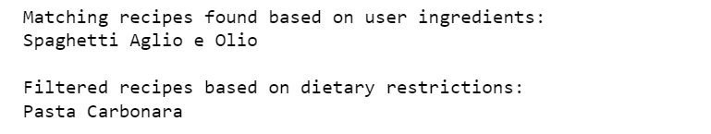

**QUESTION NO 2:**

class InventoryControlSystem:

def __init__(self):

self.inventory = {}

def add_product(self, product_id, product_name, price, quantity):

if product_id in self.inventory:

print("Product ID already exists. Use update_product_quantity to modify quantity.")

else:

self.inventory[product_id] = {

'product_name': product_name,

'price': price,

'quantity': quantity

}

print(f"Product {product_id} added to inventory.")

def update_product_quantity(self, product_id, new_quantity):

if product_id in self.inventory:

self.inventory[product_id]['quantity'] = new_quantity

print(f"Quantity for Product {product_id} updated.")

else:

print("Product ID not found in inventory.")

def remove_product(self, product_id):

if product_id in self.inventory:

del self.inventory[product_id]

print(f"Product {product_id} removed from inventory.")

else:

print("Product ID not found in inventory.")

def check_product_availability(self, product_id):

if product_id in self.inventory:

available_quantity = self.inventory[product_id]['quantity']

print(f"Product {product_id} is available. Available Quantity: {available_quantity}.")

else:

print("Product ID not found in inventory.")

def display_inventory(self):

print("Inventory Details:")

for product_id, details in self.inventory.items():

print(f"Product ID: {product_id}, Name: {details['product_name']}, Price: {details['price']}, "

f"Quantity: {details['quantity']}")

def add_new_product(self, product_id, product_name, price, quantity):

if product_id in self.inventory:

print("Product ID already exists. Use update_product_quantity to modify quantity.")

else:

self.add_product(product_id, product_name, price, quantity)

def update_product_details(self, product_id, product_name=None, price=None, quantity=None):

if product_id in self.inventory:

if product_name:

self.inventory[product_id]['product_name'] = product_name

if price:

self.inventory[product_id]['price'] = price

if quantity:

self.inventory[product_id]['quantity'] = quantity

print(f"Details for Product {product_id} updated.")

else:

print("Product ID not found in inventory.")

inventory_system = InventoryControlSystem()

inventory_system.add_product(1, "T-shirt", 15.99, 50)

inventory_system.add_product(2, "Jeans", 29.99, 30)

inventory_system.add_product(3, "Shoes", 49.99, 20)

inventory_system.display_inventory()

inventory_system.check_product_availability(2)

inventory_system.update_product_details(2, product_name="New Jeans", price=39.99, quantity=40)

inventory_system.display_inventory()

inventory_system.remove_product(3)

inventory_system.display_inventory()

inventory_system.add_new_product(4, "Socks", 5.99, 100)

inventory_system.display_inventory()

**OUTPUT**

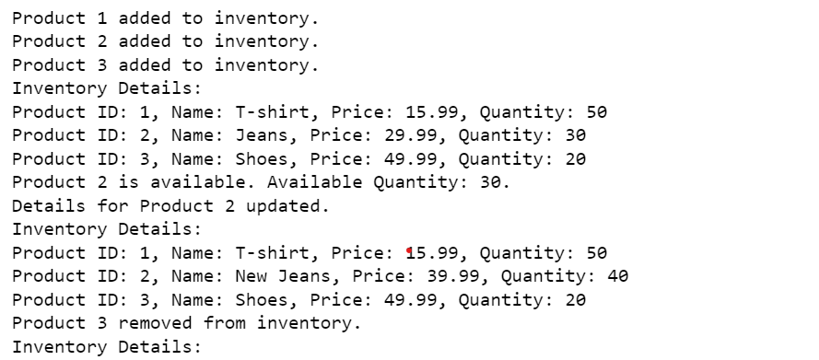

**QUESTION NO 3:**

import random

def generate_random_array(rows, cols):

return [[random.randint(1, 100) for _ in range(cols)] for _ in range(rows)]

def write_array_to_file(array, filename):

with open(filename, 'w') as file:

for row in array:

file.write(' '.join(map(str, row)) + '\n')

def read_array_from_file(filename):

with open(filename, 'r') as file:

return [[int(num) for num in line.split()] for line in file]

def print_spiral_order(matrix):

rows = len(matrix)

cols = len(matrix[0])

top, bottom, left, right = 0, rows - 1, 0, cols - 1

direction = 0

while top <= bottom and left <= right:

if direction == 0:

for i in range(left, right + 1):

print(matrix[top][i], end=" ")

top += 1

elif direction == 1:

for i in range(top, bottom + 1):

print(matrix[i][right], end=" ")

right -= 1

elif direction == 2:

for i in range(right, left - 1, -1):

print(matrix[bottom][i], end=" ")

bottom -= 1

elif direction == 3:

for i in range(bottom, top - 1, -1):

print(matrix[i][left], end=" ")

left += 1

direction = (direction + 1) % 4

random_array = generate_random_array(5, 5)

write_array_to_file(random_array, 'random_array.txt')

read_array = read_array_from_file('random_array.txt')

print("Array read from file:")

for row in read_array:

print(row)

print("\nSpiral Order:")

print_spiral_order(read_array)

